Robot Framework

CapGEMINI INDIA

Installation guide

raHIL SHAIKH

Step-wise installation of Robot Framework

**Step 1: Install Python 2.7 version**

Install Python 2.7 (python-2.7.13.msi preferred)

Note: we are installing python-2.7.13.msi as it contains PIP inbuilt

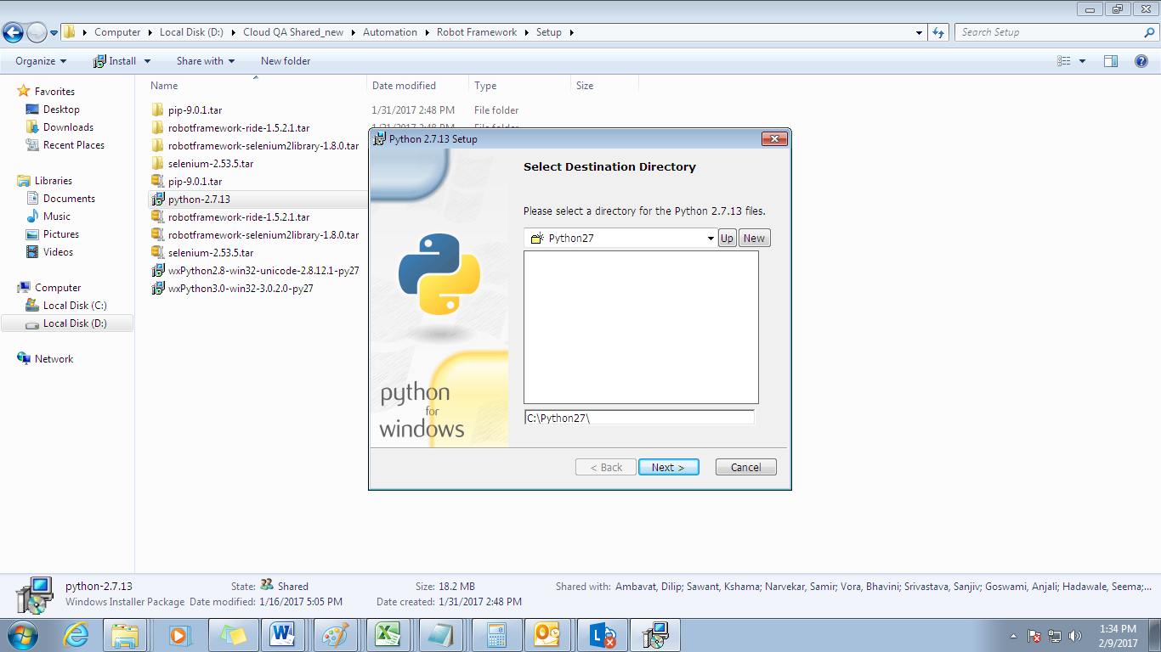

**Step 2: Verify Python 2.7 version**

**Type command** python –version

command result will be

Python 2.7.6

**Step 3: Install wxpython (wxPython2.8-win32-unicode-2.8.12.1-py27.exe OR**

**wxPython2.8-win64-unicode-2.8.12.1-py27.exe)**

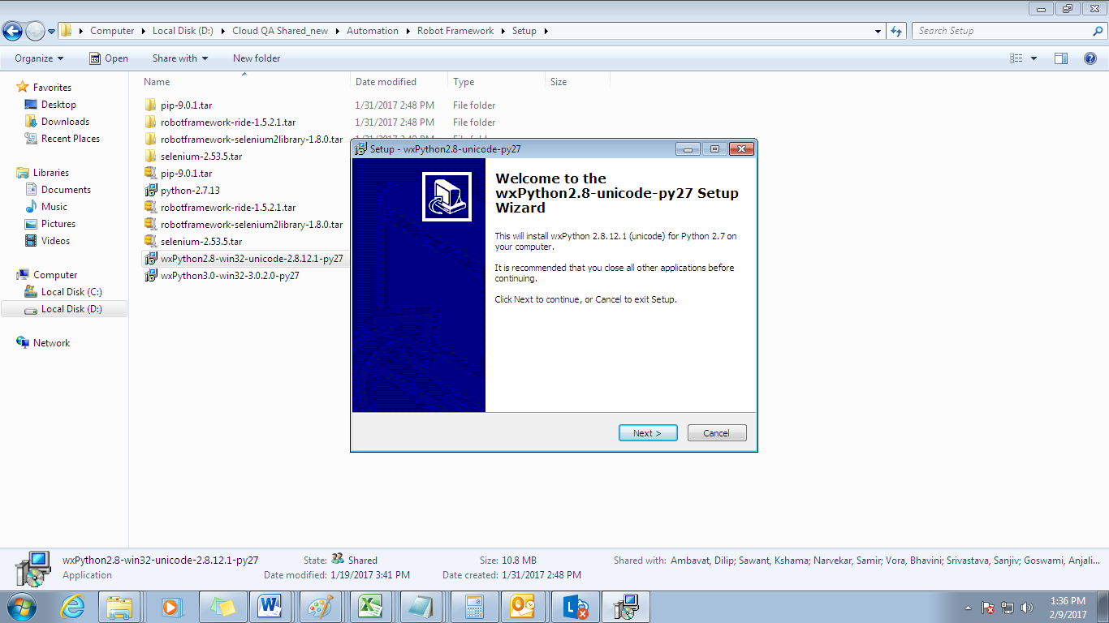

**Step 4: Set variable PATH**

**Set variable PATH as C:\Python27;C:\Python27\Scripts in User variables**

* Select Start, select Control Panel. double click System, and select the Advanced tab.
* Click Environment Variables. ...
* In the Edit System Variable (or New System Variable) window, specify the value of the PATH environment variable.
* *See below screenshot for reference*

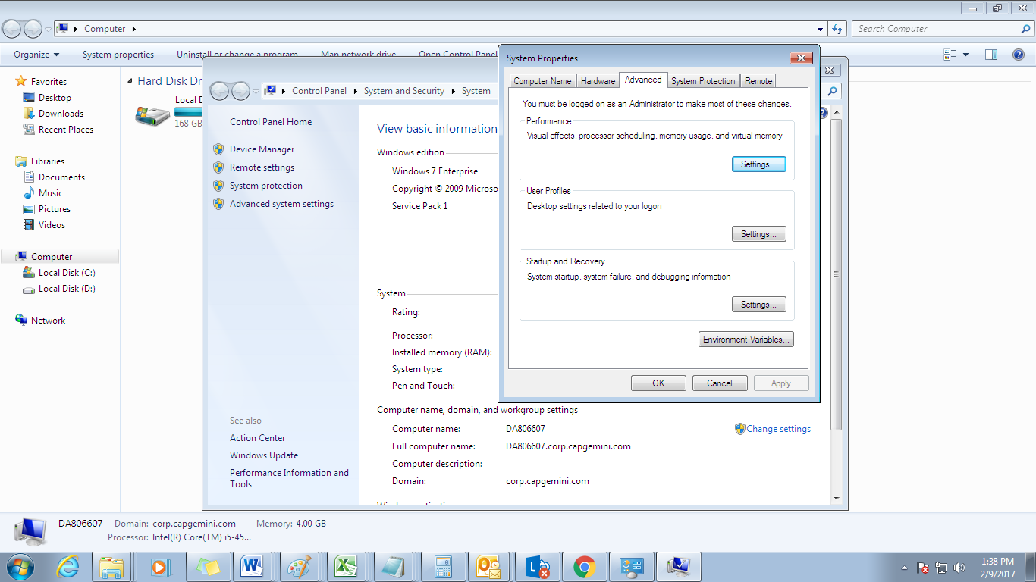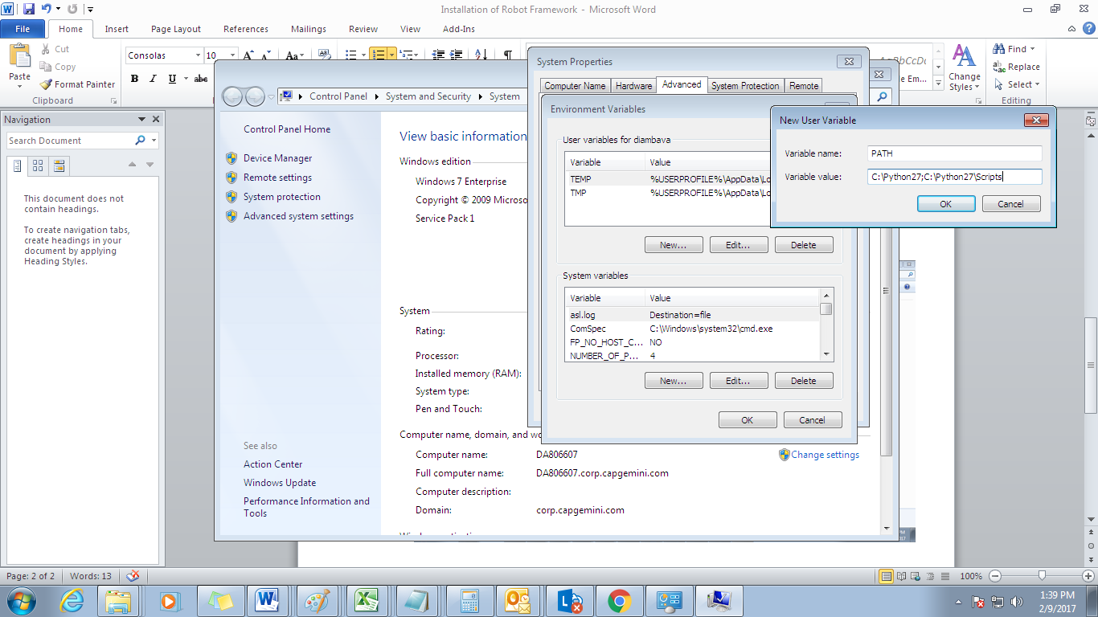

**Step 5: Install Robot Framework**

Open cmd, Go to C:\Python27 prompt and execute below command

python -m pip install robotframework

**or command** pip install robotframework

After a successful installation with Python, you should be able to execute the following commands on the command prompt to verify the installation.

pybot --version

**Command Result**

Robot Framework 2.8.4 (Python 2.7.6 on win32)

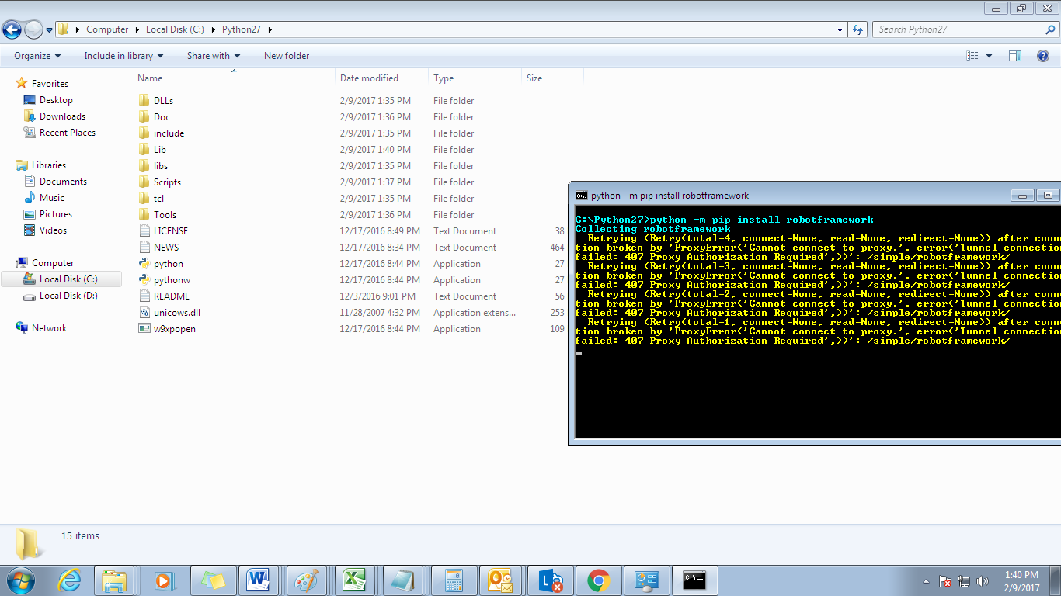

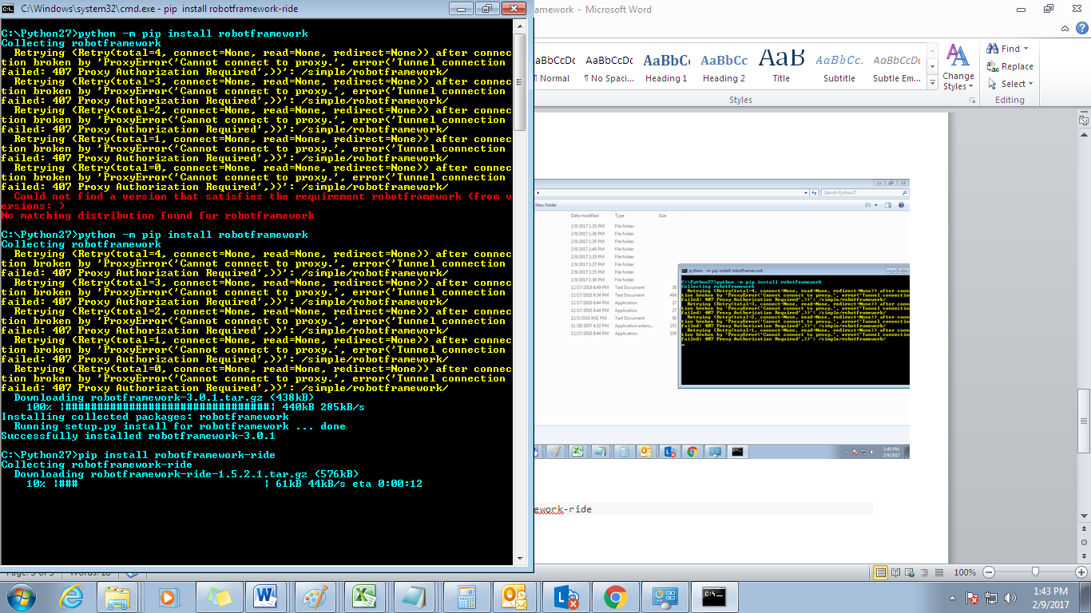

**Step 6: Install Selenium2 Library**

Use the following command to install robotframework-selenium2library with pip.

pip install robotframework-selenium2library

**Step 7: Install Selenium Library**

Use the following command to install robotframework-selenium2library with pip.

pip install -U selenium

**Step 8:** Place browser driver at path C:\Python27

**Step 9: Install RIDE (Robot IDE)**

To install RIDE, you can use pip with the following command.

pip install robotframework-ride

**Step 10: Verify RIDE Installation**

After a successful installation, RIDE can be started from the command line by running

ride.py

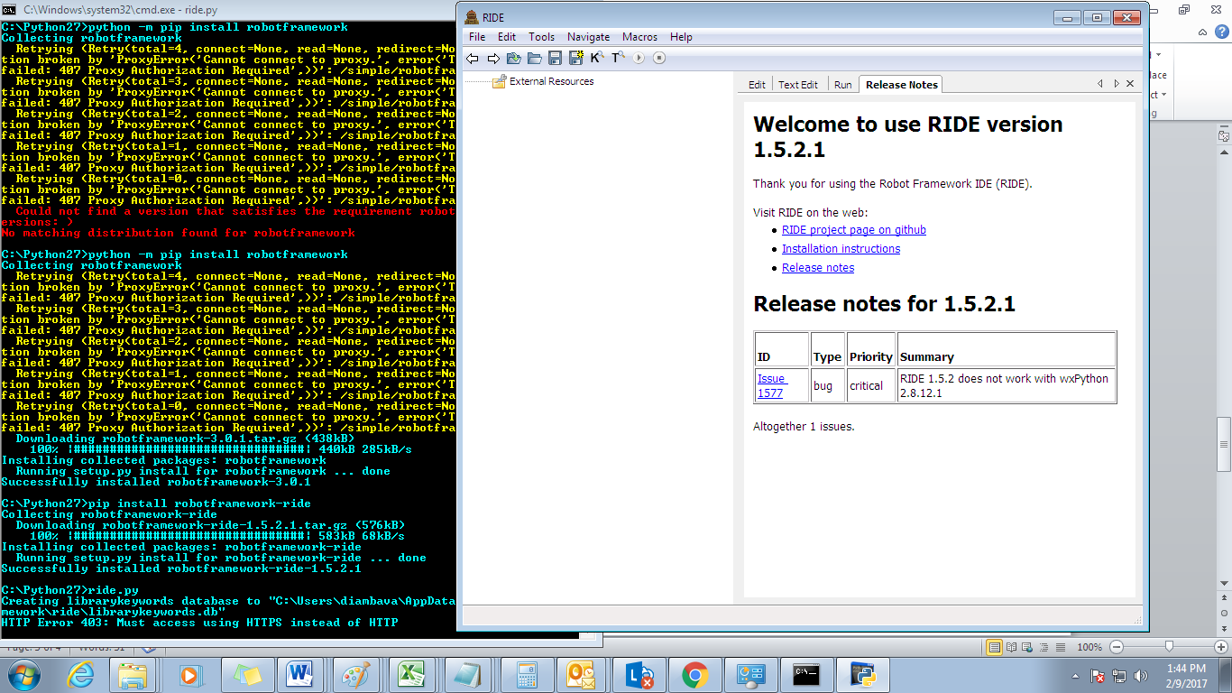

***For more info, please visit :*** <https://github.com/robotframework/robotframework/blob/master/INSTALL.rst>